National Standards of Practice Overview
The Veterans Health Administration (VHA) is developing national standards of practice (NSPs) to ensure Veterans receive the same high-quality and safe care regardless of where they enter the Department of Veterans Affairs (VA) integrated health care system. These standards are designed to increase health care access, improve health outcomes for Veterans, and protect our health care providers from adverse actions as they carry out their duties as VA employees.
Development and Engagement Process
VA is committed to a clear, inclusive, and transparent development process. Stakeholder engagement and input are integral to the success of this initiative. The NSP development and engagement process is designed to ensure all stakeholders are provided with an opportunity to provide feedback at various stages throughout the process.
The process begins at step 1, with establishing workgroups of VHA subject matter experts to develop occupation specific NSPs.
At step 2, workgroups conduct State variance research and outreach to internal stakeholders. In some cases, VHA may seek informal feedback from external groups who may be able to provide information relevant to this research phase.
At step 3, the workgroups draft the NSPs using best practices, addressing State variances, and incorporating stakeholder feedback as appropriate. Each workgroup also develops an engagement plan with an overview of planned outreach.
The NSPs go through a comprehensive internal VHA review process in step 4 to receive VHA Senior Leader approval in step 5.
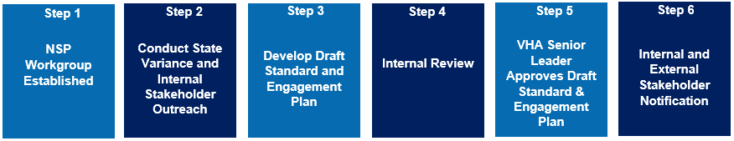
At step 6, VA shares the draft NSP with Congress and VHA Labor Unions for additional input. Once complete, the standard is posted on the Federal Register for public comment for a period of 60 days to ensure all internal and external stakeholders have an opportunity to review and provide comments for VA to consider prior to publication in the next step. We anticipate the first standards will be posted in the Federal Register for public comment by early 2022. This period provides health care professionals ample opportunity to comment on each NSP.
Concurrently, VA will engage with State Boards. VA will send every State Board a letter with information on the impact of the draft NSP on the specific state, with an opportunity for the State Board to respond. Engagement with professional practice organizations will continue and may include invitations to listening session or request for specific feedback.
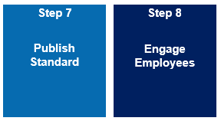
At step 7, VA publishes the standard with a delayed effective date. At step 8, between publication and effective date, VA will further engage with VA employees to ensure effective implementation of the standard.
While the length of time to develop each NSP varies, it is anticipated that no NSPs will become effective before April 2022, and some NSPs may take up to 2 years. As the NSPs are further developed, stakeholder engagement, collaboration, and input are highly encouraged to be shared with VHASupremacyTeam@va.gov for consideration throughout the entirety of the development process.

